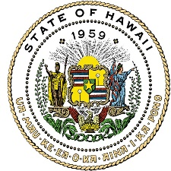
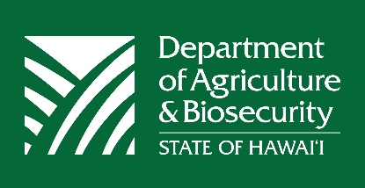
Market Analysis and News Branch
1428 South King Street
Honolulu, HI 96814-2512
In Cooperation with the United States Department of Agriculture
National Agricultural Statistics Service, Pacific Region

Statistics on Grading Standards for Hawaiʻi’s Green Coffee
State of Hawaiʻi, 2023 – 2025

The Hawaiʻi Administrative Rules, Chapter 4-143, outlines coffee standards and the certification process for Hawaiʻi’s green coffee to safeguard the geographic identity of Hawaiʻi-grown coffee and to ensure product quality and origin for buyers.¹ The Commodities Branch at the Hawaiʻi Department of Agriculture and Biosecurity is responsible for inspecting and certifying green coffee produced in Hawaiʻi. Grading is based on cleanliness, color, roasting quality, allowance for defects, size minimum, and moisture content. The standards for grades of green coffee include Extra Fancy, Fancy, Hawaii No.1, Select, Prime, Hawaii No.3, Natural Prime, Mixed Natural Prime, and Off Grade. Coffee with a quality lower than Prime is prohibited from using geographic terms such as “Hamakua”, “Kau”, “Kauai, “Kona”, “Maui, “Molokai”, or “Oahu” on its product label.²

Prime was the predominant grade produced by Hawaiʻi’s green coffee producers, accounting for 72% of all green coffee certified by the Commodities Branch during the 2024-2025 season, followed by Select (13%) and Hawaii No.3 (8%). However, the share of major standard grades like Prime changed to some extent each season. For example, in the 2024-2025 season, the share of Prime decreased considerably, compared to the previous 2023-2024 season, largely due to the increase of Select. Additionally, according to the USDA NASS, utilized production of green coffee in Hawaiʻi was estimated at 3.9 million pounds in the 2024-2025 season. It suggests that only about half of Hawaiʻi’s utilized green coffee was graded and certified in the 2024-2025 season. However, as shown in Table 1, the share of utilized green coffee certified by the Commodities Branch may fluctuate from year to year. The certification of green coffee is a voluntary program in Hawaiʻi; therefore, green coffee producers may or may not choose to certify their green coffee due to various reasons.

Table 1: Hawaiʻi Green Coffee Production (Unit in Pounds) and Grading Standards, 2023 – 2025
Grading Standards | 2023-2024 | % | 2024-2025 | %
Extra Fancy | 31,300 | 1.3 | 23,621 | 1.2
Fancy | 36,500 | 1.5 | 34,352 | 1.7
Hawaii No.1 | 43,692 | 1.8 | 30,159 | 1.5
Select | 26,047 | 1.1 | 270,356 | 13.3
Prime | 1,870,583 | 78.3 | 1,453,974 | 71.7
Hawaii No.3 | 375,394 | 15.7 | 171,907 | 8.5
Natural Prime | 1,187 | 0.0 | 4,075 | 0.2
Mixed Natural Prime | 3,727 | 0.2 | 25,140 | 1.2
Off Grade | 0 | 0.0 | 13,876 | 0.7
Total Volume of Green Coffee Certified | 2,388,430 | 100 | 2,027,460 | 100
Total Utilized Production of Green Coffee ³ | 3,440,000 |  | 3,961,000
Proportion of Hawaiʻi Green Coffee Certified | 69% |  | 51%
Source: Commodities Branch, Quality Assurance Division, Hawaiʻi Department of Agriculture and Biosecurity.
¹ https://dab.hawaii.gov/wp-content/uploads/2012/12/AR-143.pdf
² https://dab.hawaii.gov/qad/files/2020/07/2020-Coffee-HAR-143-Summary-Defects-Allowance-back-to-15-eff-July1.pdf
³ USDA NASS Hawaii Coffee: https://esmis.nal.usda.gov/sites/default/release-files/3t945q80c/cn69nz03f/7w62h548q/cafean25.pdf
Chart 1: Hawaiʻi Green Coffee Production and Grading Standards, 2023 – 2024 & 2024 – 2025

Chart 2: Distribution of Hawaiʻi Green Coffee Standards, 2023 – 2024 & 2024 – 2025

###
The Department of Agriculture and Biosecurity (DAB) is committed to maintaining an environment free from discrimination, retaliation, or harassment on the basis of race, color, sex, national origin, age, or disability, or any other class as protected under federal or state law, with respect to any program or activity. More information is available at DAB’s website: http://dab.hawaii.gov/.

