

Market Analysis and News Branch
1428 South King Street Honolulu, HI 96814-2512

Market Analysis: Egg Price Dynamics in Honolulu

Reporting Period: Quarter 4, 2024 – Quarter 4, 2025

This report analyzes egg price fluctuations in the Honolulu retail market by integrating local data with broader U.S. national trends. The 2025 calendar year was characterized by a severe supply-driven price spike in Q1, followed by a fragmented recovery. While national wholesale prices normalized quickly, Honolulu retail prices exhibited significant "stickiness," particularly within the local production sector.

1. Market Volatility & National Drivers: The “Sticky” Retail Lag
Honolulu’s egg market remains highly susceptible to mainland supply shocks. Chart 1 (U.S. Retail Average) and Chart 2 (National Wholesale Index) show that a massive national price spike occurred in early 2025. This was driven by a supply crunch (avian flu outbreak), causing the national index to skyrocket to peaks between $6.00 and $8.00 per dozen. While wholesale prices in Chart 2 corrected sharply by mid-2025, retail prices in Chart 1 remained "sticky," taking longer to decline—a trend mirrored in the Honolulu data. Consumers in Honolulu did not see immediate relief; retail prices lagged behind the wholesale recovery by several months.

2. Conventional Egg Impact (Table 1)
Conventional eggs in Honolulu market bore the brunt of the 2025 volatility. Both local and U.S. mainland imports saw surges of 20–30% during the Q1 peak. As mainland supply stabilized, imported egg prices in Honolulu aggressively corrected, eventually dropping below late-2024 levels by Q4 2025. However, local conventional eggs showed significantly more resistance to price drops. The benchmark 12 carton local conventional eggs, ended the year at $8.38—a 5.5% increase over the year—creating a wide 20% price gap between local and imported eggs by year-end.

3. Organic Stability & Supply Gaps (Table 2)
The organic market prioritized price stability over availability but this came at the expense of shelf availability. Local Organic prices remained remarkably static, ending the year with a negligible 1.3% total change. This stability has masked severe inventory issues. During periods of peak national stress, specialty items—specifically 18-packs—were virtually unavailable in the Honolulu market. Interestingly, by Q4 2025, the price of U.S. Organic dozen eggs ($8.55) dropped so much that they became cheaper than some local conventional eggs.

Table 1: Conventional Egg Price in the Honolulu Market, Quarter 4, 2024 to Quarter 4, 2025
Origin | CT Size | Qtr. 4, 2024 | Qtr. 1, 2025 | Qtr. 3, 2025 | Qtr. 4, 2025 | Qtr. 4, 2024 | Qtr. 1, 2025 | Qtr. 3, 2025 | Qtr. 4, 2025
Origin | CT Size | Avg. Price |  |  |  | Price Range
Local | 12 | $7.94 | $9.51 | $9.84 | $8.38 | $6.49-$10.79 | $6.49-$11.79 | $6.99-$11.99 | $5.29-$10.49
 | 18 | $11.18 | $14.05 | $14.55 | $11.68 | $9.99-$12.99 | $10.49-$15.99 | $13.49-$15.99 | $5.99-$14.49
U.S. | 12 | $7.28 | $9.46 | $8.48 | $6.97 | $5.49-$8.99 | $6.49-$10.99 | $4.97-$10.99 | $3.74-$8.49
 | 18 | $11.18 | $14.17 | $12.85 | $9.25 | $8.99-$13.79 | $8.99-$15.99 | $7.54-$15.99 | $4.86-$12.49

Table 2: Organic Egg Price in the Honolulu Market, Quarter 4, 2024 to Quarter 4, 2025
Origin | CT Size | Qtr. 4, 2024 | Qtr. 1, 2025 | Qtr. 3, 2025 | Qtr. 4, 2025 | Qtr. 4, 2024 | Qtr. 1, 2025 | Qtr. 3, 2025 | Qtr. 4, 2025
Origin | CT Size | Avg. Price |  |  |  | Price Range
Local | 12 | $10.13 | $10.16 | $11.97 | $10.26 | $7.59-$14.49 | $7.99-$11.99 | $8.99-$14.98 | $8.99-$11.49
 | 18 | N/A | N/A | N/A | N/A | N/A | N/A | N/A | N/A
U.S. | 12 | $9.11 | $9.49 | $9.62 | $8.55 | $5.89-$11.58 | $9.49-$9.99 | $9.49-$9.99 | $7.29-$9.99
 | 18 | $10.49 | N/A | $13.99 | $13.99 | $9.99-$10.99 | N/A | $13.99-$13.99 | $13.99-$13.99

Chart 1: U.S. Average Egg Price Per Dozen at Retail, October 2023 to December 2025

Source: U.S. Bureau of Labor Statistics. Eggs, Grade A, Large, Per Dozen, in U.S. City Average, Average Price.
available at: https://data.bls.gov/timeseries/APU0000708111 (accessed December 26, 2025). October data was
unavailable due to the 2025 lapse in appropriations.
Chart 2: U.S. Weekly Loose Shell Egg, Large, White, National Index¹
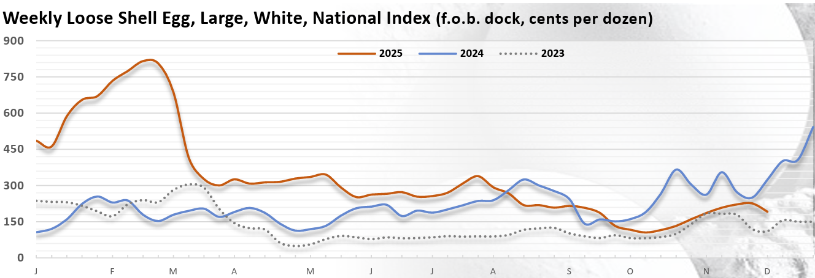
Source: USDA-AMS, Livestock and Poultry Program, Egg Markets Overview. December 05, 2025.
¹ F.O.B, Dock, cents per dozen. Available at: https://www.ams.usda.gov/mnreports/ams_3725.pdf (accessed
December 26, 2025)

###
The Department of Agriculture and Biosecurity (DAB) is committed to maintaining an environment free from discrimination, retaliation, or harassment on the basis of race, color, sex, national origin, age, or disability, or any other class as protected under federal or state law, with respect to any program or activity. More information is available at DAB’s website: https://dab.hawaii.gov/

